**Exercise 8: Online Bookstore - Implementing CRUD Operations**

Business Scenario:

Implement Create, Read, Update, and Delete operations for the Book and Customer entities.

1. **CRUD Endpoints:**

I implemented endpoints for creating, reading, updating, and deleting books and customers in the BookController and CustomerController classes respectively

BookController.java:

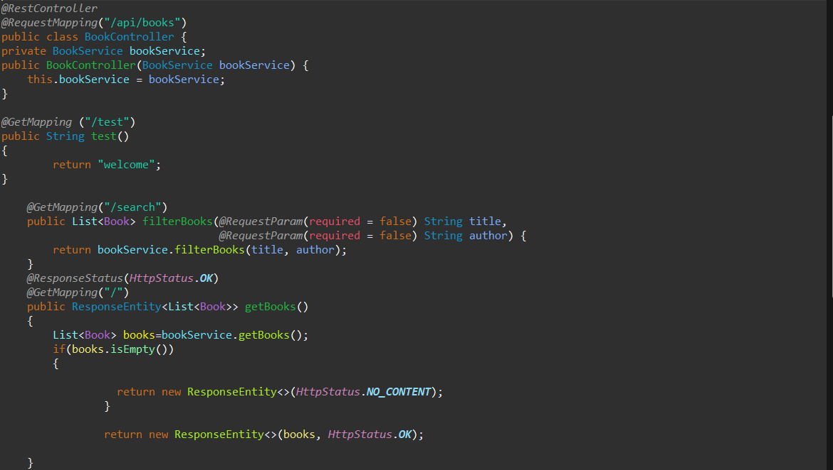

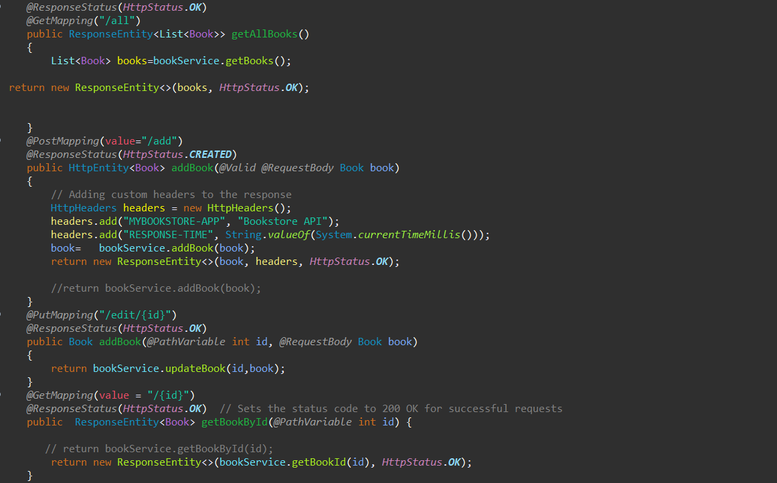

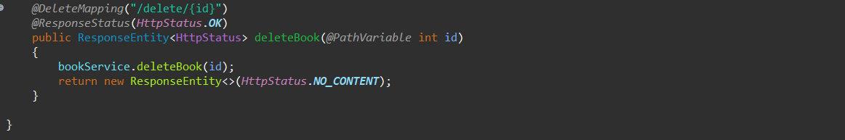

CustomerController.java

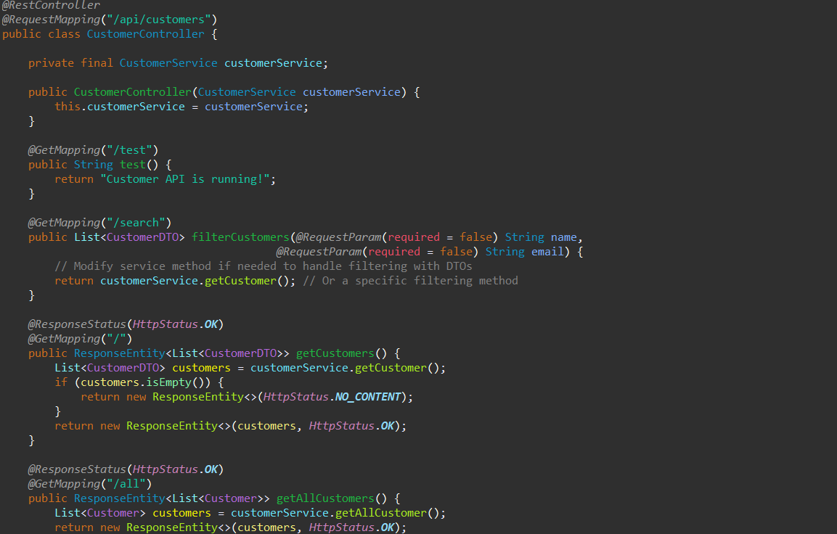

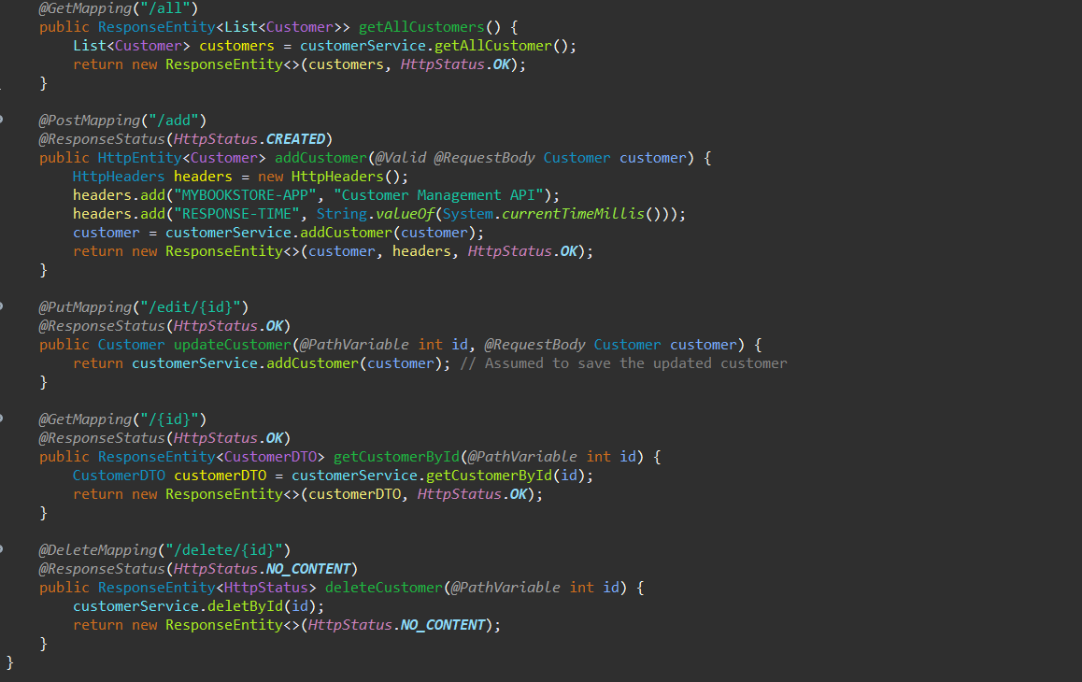

1. Validating input data:

* I used validation annotations like **@NotNull, @Size**, and **@Min** to validate input data for both Book class and Customer class

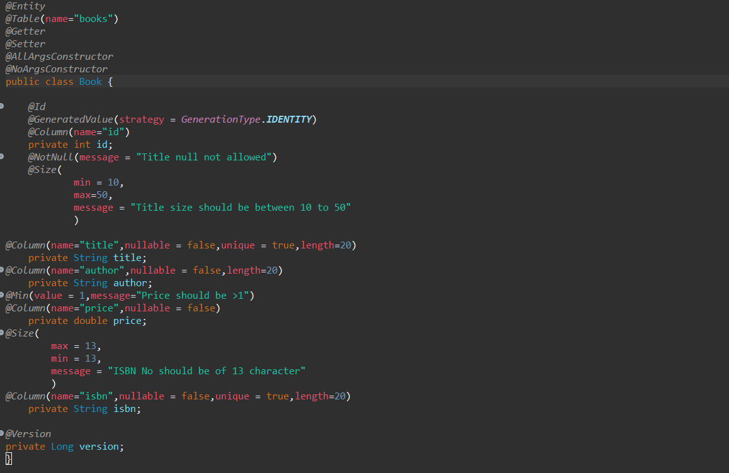

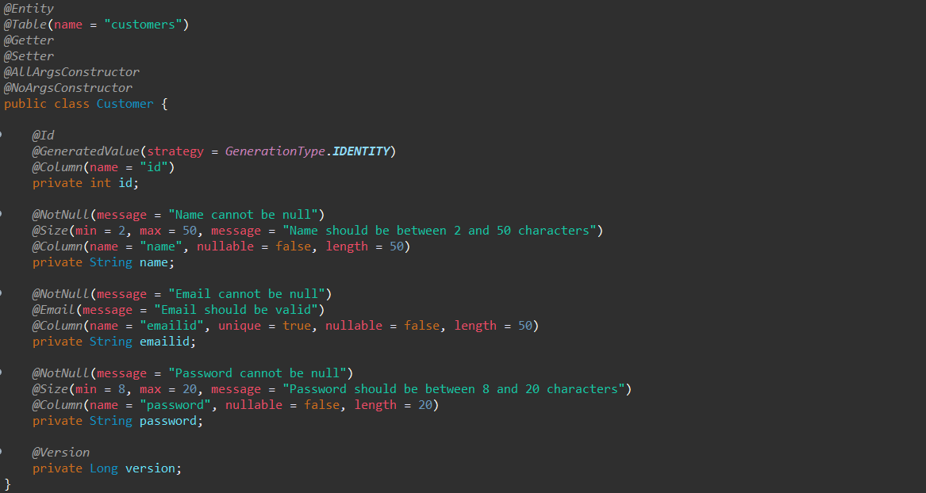

1. Optimistic Locking:

* I implemented optimistic locking for concurrent updates using JPA Versioning using @Version in both Book and Customer classes



**Output:**

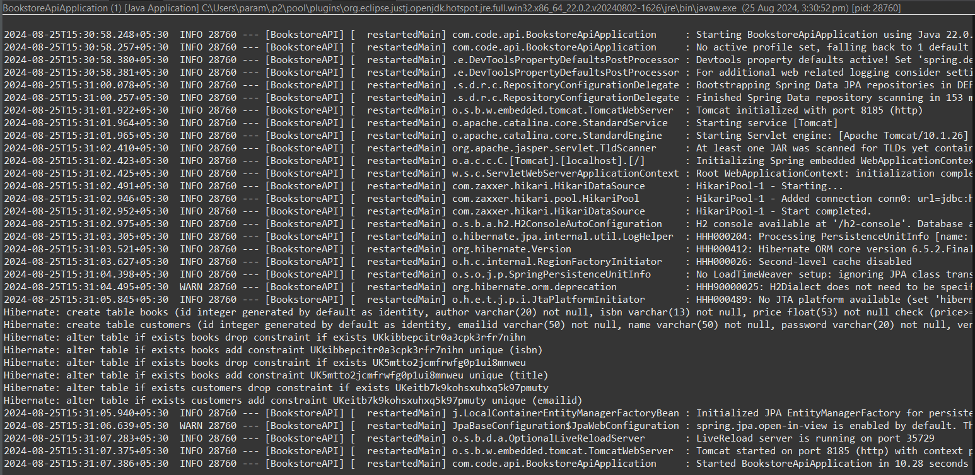

While adding book if the ISBN is below 13 characters:

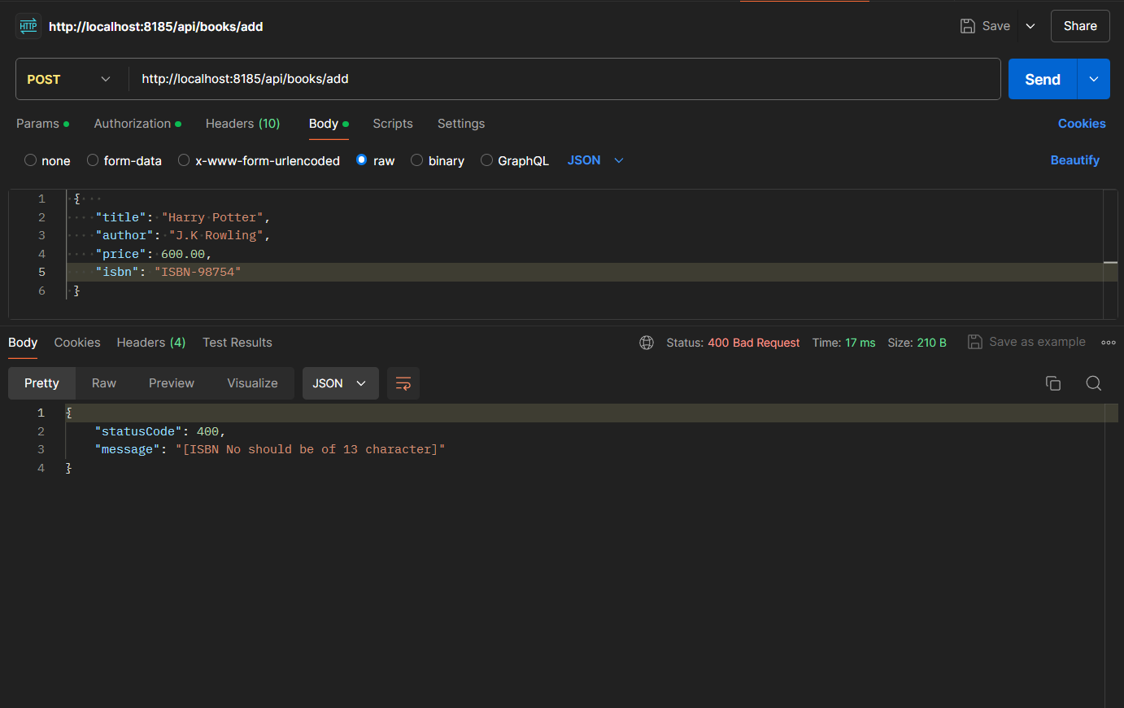

Add Books:

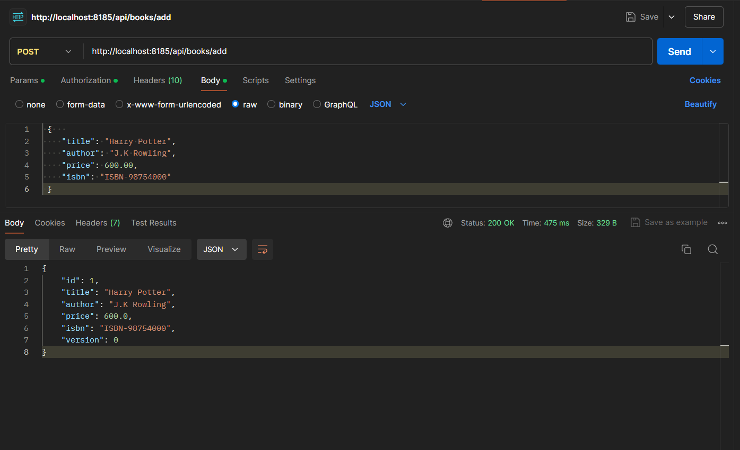

While adding book if the title is below 10 characters:

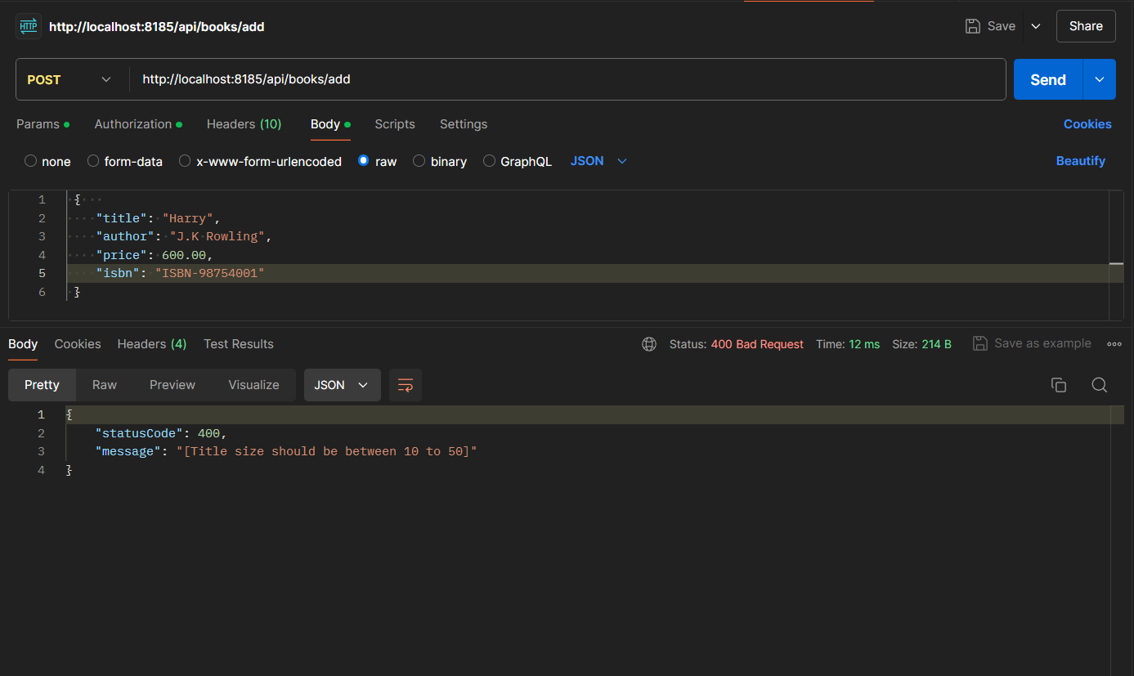

If book to be added is having same ISBN as of another book:

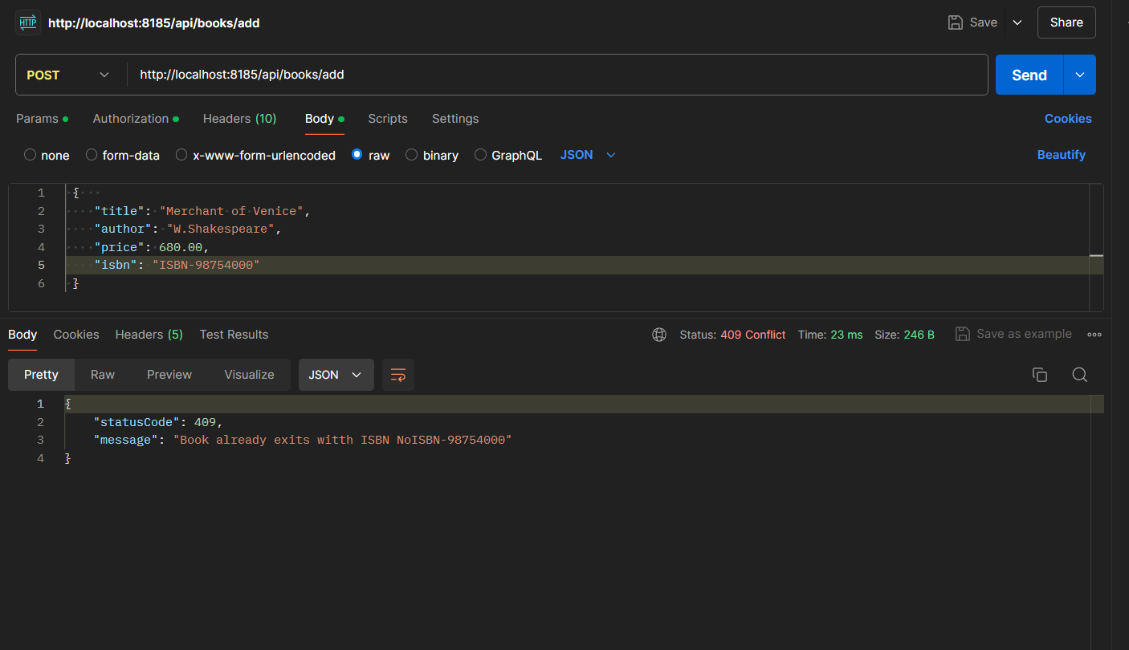

While adding book if the price is set as 0.00:

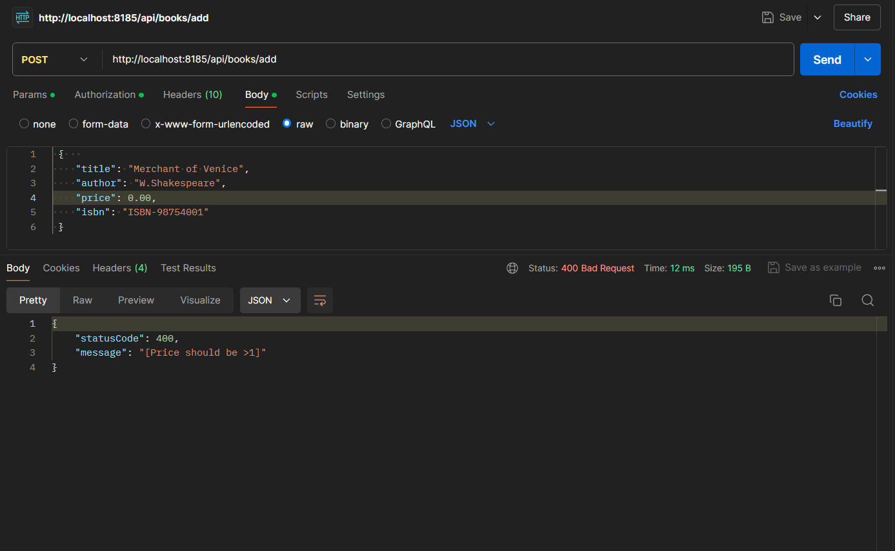

Adding another book:

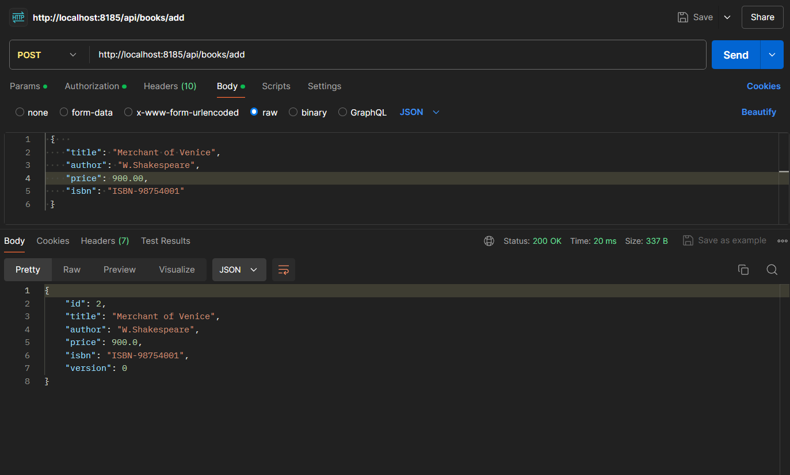

Adding a new Customer:

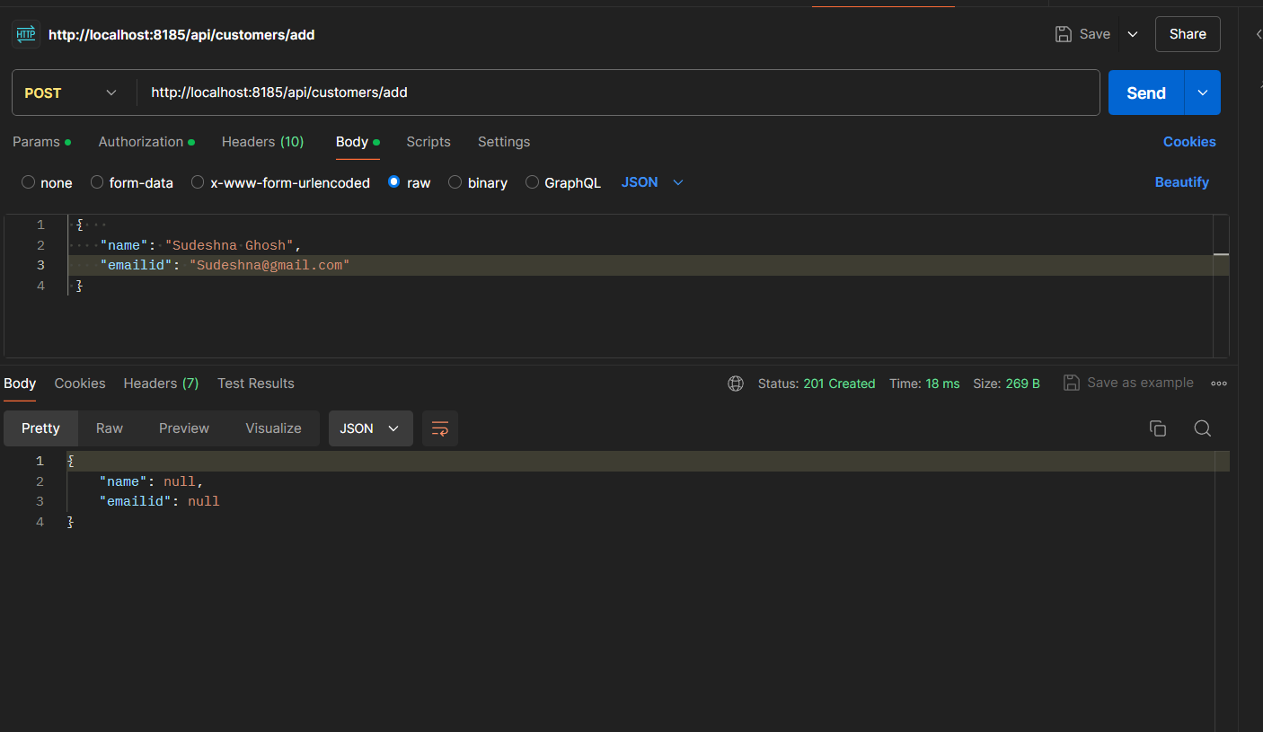

While adding is the name of the Customer is below 2 characters:

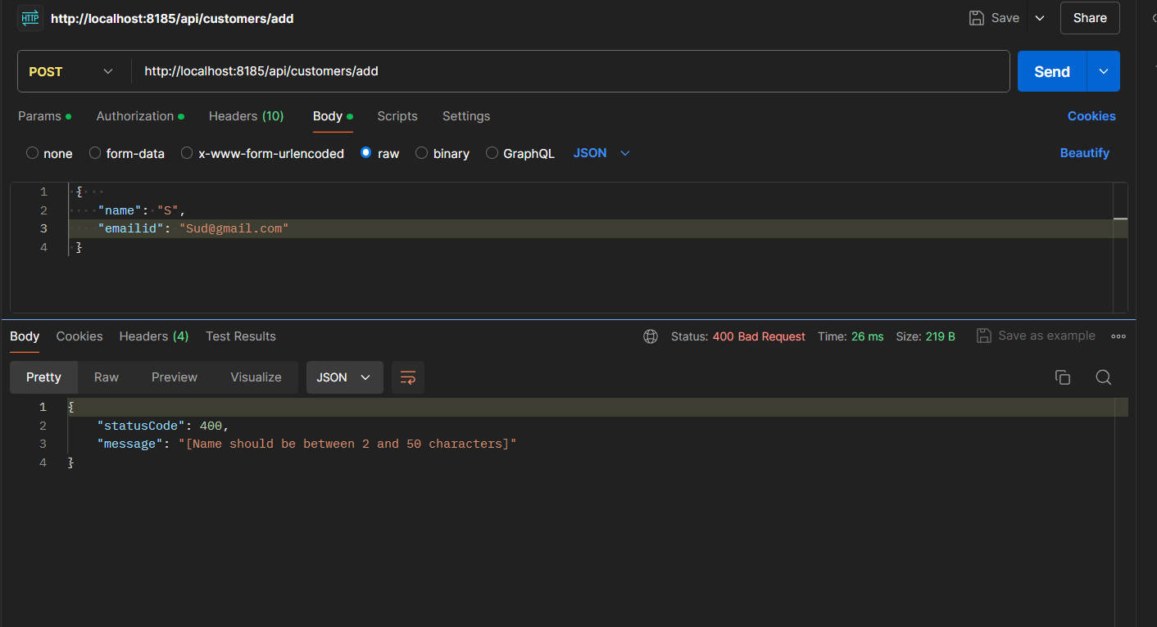

Adding a new customer:

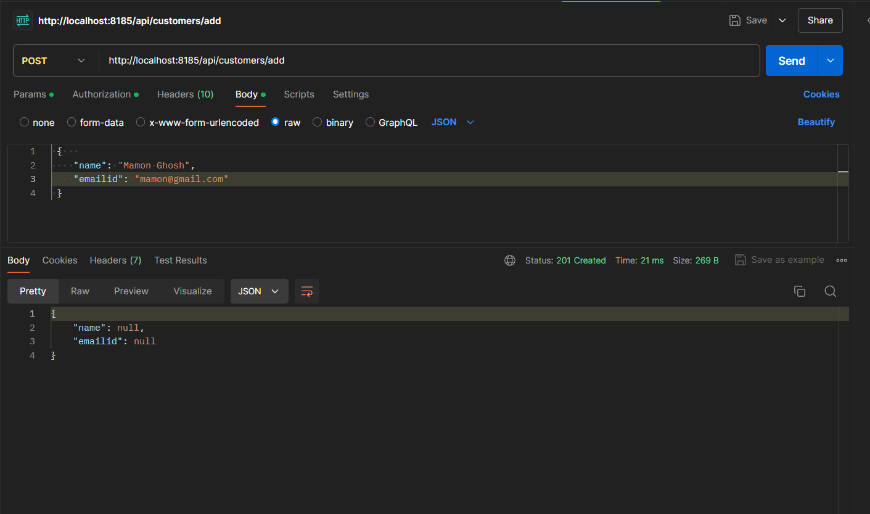

While adding customer if the email is same:

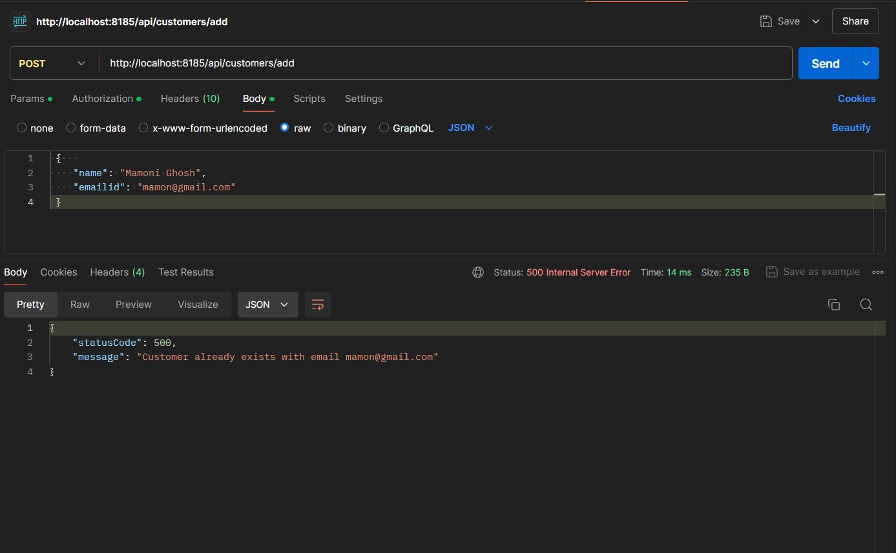

GET:

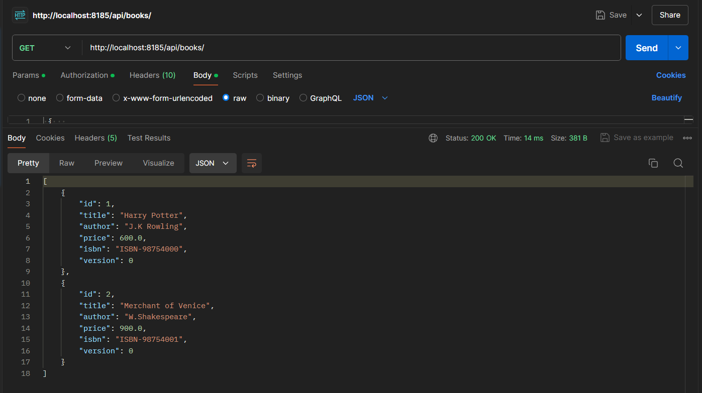

Customer not found:

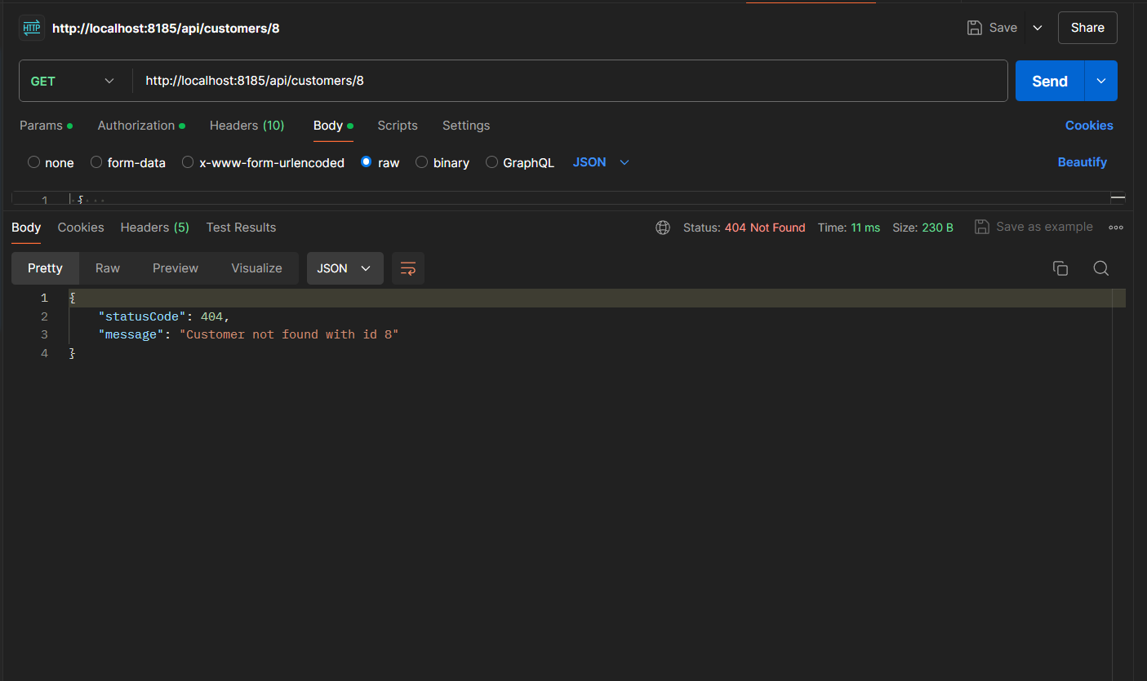

Removing and Adding other books for PUT and DELETE:

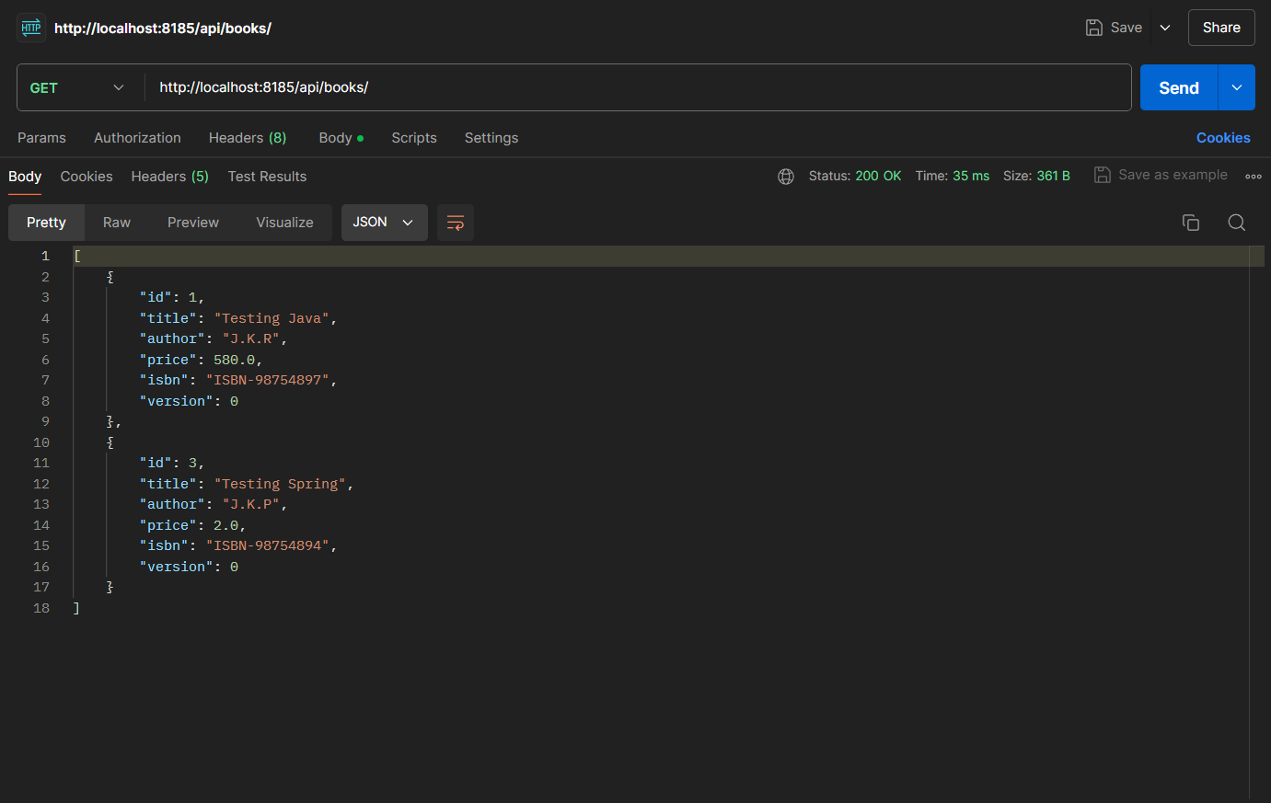

PUT:

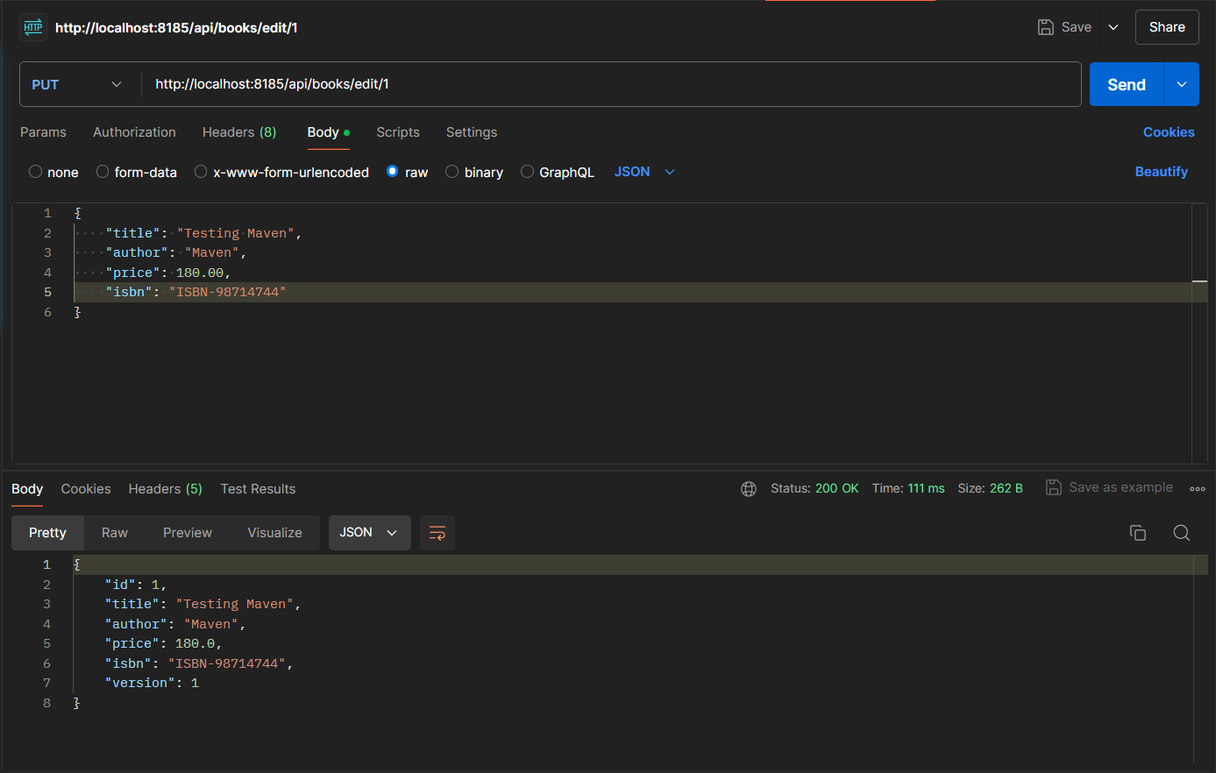

DELETE:

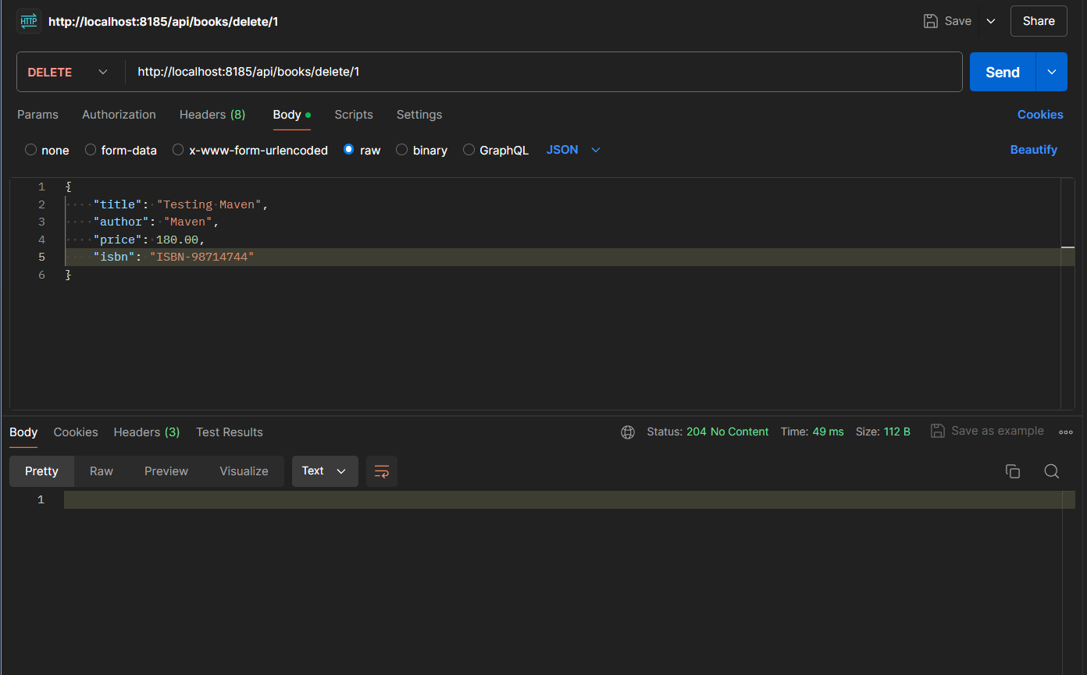

Book not found:

